Project plan

  - Project System
  - Company: ThunderBolt ARTRT

Place, date: Enschede, 29st February 2024
Drawn up by: Brian Willians
Karolina Gogolin
Nhât Ha Pham
Stefan Mutafov
Thais Tereza Cataldi Beirao
Version: 1.1

Place, date: | Enschede, 29 February 2024
Drawn by: | ThunderBolt ART
Chapter 1 | Brian Williams | 559296 | 559296@student.saxion.nl
Chapter 2 | Thais Tereza Cataldi Beirao | 549098 | 549098@student.saxion.nl
Chapter 3 | Thais Tereza Cataldi Beirao | 549098 | 549098@student.saxion.nl
Chapter 4 | Brian Williams | 559296 | 559296@student.saxion.nl
Chapter 5 | Stefan Mutafov | 543838 | 543838@student.saxion.nl
Chapter 6 | Karolina Gogolin | 543772 | 543772@student.saxion.nl
Chapter 7 | Nhật Hà Phạm | 547508 | 547508@student.saxion.nl
Chapter 8 | Thais Tereza Cataldi Beirao | 549098 | 549098@student.saxion.nl
Chapter 9 | Brian Williams | 559296 | 559296@student.saxion.nl
Version number: | [1.0]: Names updated
 | [1.1]: General first draft update
 | [1.2]: Final Draft
Clients: | Saxion LED, Lydia Prieto Leon, Ali Yuksel
Table I-1

Responsibility
 | Process manager  name | Product developer  name | Objective
Student 1 | Stefan Mutafov | Karolina Gogolin | Avoiding obstacles and finding the line
Student 2 | Nhật Hà Phạm | Thais Tereza | Stopping the car at the end of the track and 3D printing parts
Student 3 | Nhật Hà Phạm | Brian Williams | Going up and down the hill
Student 4 | Stefan Mutafov | Stefan Mutafov | Following the 20mm white line
Student 5 | Nhật Hà Phạm | Nhật Hà Phạm | Making sure the car operates for at least 30 minutes
Table I-2
Table of Contents
I. List of figures v
I. Abbreviations vi
1 Introduction 1
1.1 Background 1
1.2 Purpose of the Assignment 1
1.3 Methodological approach 1
1.4 Report outline 2
2 Project Objectives 3
2.1 Objectives 3
Main Objectives: 3
Research objectives 3
2.2 Execution of the project 4
2.3 SMART 4
3 Project Activities 7
3.1 Different phases 7
1st Phase: Project Setup - Requirements/Analysis 7
2nd Phase: Design Phase – Functional and Technical 7
3rd Phase: Realisation/ Implementation. 7
4th Phase: Test Phase 7
5th Phase: Final test. 8
3.2 Activities 8
1st Phase: Project Setup - Requirements/analysis 8
2nd Phase: Design Phase – Functional and Technical 8
3rd Phase: Implementation and Realization 8
4th Phase: Testing 8
5th Phase: Final test. 8
4 Project Boundaries (scope and pre-conditions) 9
MoScoW 10
5 Products 11
5.1 Hardware 11
5.2 Software 11
5.3 Documentation 11
6 Quality assurance 12
6.1 Hardware 12
6.2 Software 12
6.3 Documentation 12
7 Project organization 14
7.1 Organisation 14
7.2 Information 15
8 Planning 16
9 Risk analysis 17
9.1 Risk 17
9.2 Conclusion 17
Bibliography 18
Appendix A Gantt chart do in the other direction 19
Appendix B Risk analysis 20
Risk Assessment 20
Personnel 20
Product 21
Material Supply 22
Time Management 22

List of figures
Figure 1 Project management 7
Figure 2 XKCD graph: walking back to my front door at night 8

Abbreviations
ACS  ART  DSP  EEL | Applied Computer Sciences  Autonomous Racing Team  Digital Signal Processing  Electrical Engineering
FFT  LED(Saxion)  IR  MoSCoW  PPD  RC  SMART  TL;DR | Fast Fourier Transform  Life and Engineering Department  Infrared  Must, Should, Could, Won’t  Personal, Professional Development  Remote Control  Specific, Measurable, Attainable, Realistic, Time Constrained  Too long; didn’t read

Introduction

Background
Thunderbolt Autonomous Racing Team will design and build an autonomous RC sized car capable of following a line along a track and navigating an obstacle on that line. Thunderbolt ART is a company composed by multicultural members, with many different nationalities.
Thunderbolt ART has members from the companies The Knights of the Strongbox and Foofenschmirtz, and both companies produced products at their last project.

Purpose of the Assignment
The purpose of the assignment is to design, build and program an autonomous RC sized car. It must be capable of following a 20mm wide white line on a black background, navigate an obstacle blocking the line, then find its way back as well as climb and descend a slope on the track, in as quick a time as possible.

Methodological approach

Thunderbolt ART will follow a V-Model and break up the design of the vehicle into constituent parts within that model. This will work for the broader elements of the car, where certain parts of the design will need to be designed to specifications that suit the rest of the vehicle. However, during the design of the car there will be a necessity to change broader elements. When changes are made to the project it may be necessary to adopt a scrum methodology to adapt and overcome problems that may require a quick solution.

MoScoW

The Car MUST:
- Drive under its own power.
- Have a battery capacity for a minimum of 30 minutes operations.
- Be capable of finding the white line.
- Weigh under 3kg.
- Avoid Obstacles
- Be capable of climbing and declining a slope.
- Have a body over the engine/chassis.
- Conform to size specifications.
- Prototype should be ready by academic week 4,3.
- Car should be ready to race by week 4,6.

The Car SHOULD:
- Have a ground clearance to allow it to climb an incline.
- Optimise its electrical usage for longer life.
- Utilise a variety of sensors to detect its location and allow it to adapt to a situation.

The Car COULD:
- Incorporate a KERS system to recycle energy.
- Charge using renewable sources.
- Sound and light effects
- Change size or shape from RC/4 wheels downwards.
The Car WILL NOT:
- Not Remote Controllable
- Go Overbudget (E50)

V- Model

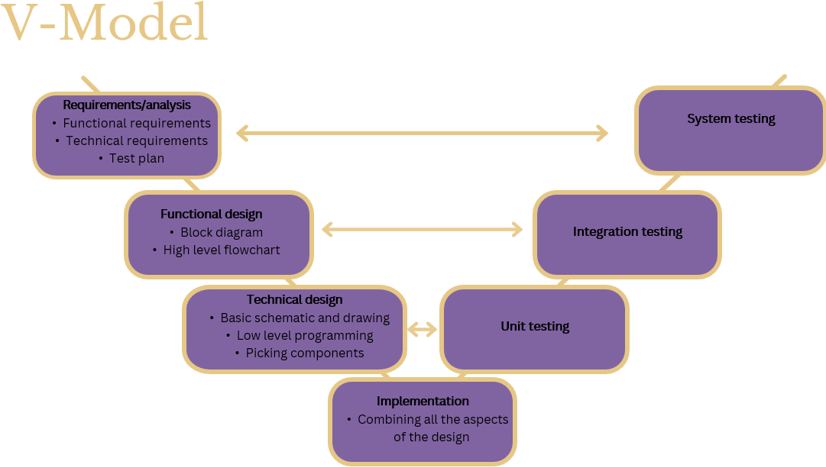
Figure 1-1

Report outline.

The following pages will contain a description of the team, the specialties of the members and the roles assigned to each person with regards to the project plan. The objectives for the project will be laid out, along with some relevant sub objectives, and the responsibility of the results expected will be outlined. From that point the plan will be outlined, including the phases of the research and development and its boundaries, and a description of the product that will be returned at the end of the project, in both software and hardware form. From that point on the report will focus in on the administrative elements of the project, with specific chapters for the quality assurance, organizations planning and the risk analysis. At the back of the report a bibliography and the appendix can be found.

Project Objectives
The objective of the Thunderbolt ART is to build an autonomous car that can follow the guidelines. It needs to follow the white line, avoid an object, climb a hill, stop at the end of the track, and its battery needs to last 30 minutes with the car functioning. The objectives for the project were provided by the client, the Saxion LED project co-ordinators.
The company will need to research and develop ways to solve problems regarding the requirements of the client while producing designs, reports, and evidence of the progress.

Objectives

Main Objectives:
  - Make a functioning autonomous car that follows a white line(20mm).
  - The car needs to go around objects.
  - The car needs to climb a hill.
  - Cars stops in the horizontal line.
  - 3D print.
  - The car can operate for 30 minutes on a full charge.

Research objectives.
  - Make a functioning autonomous car that follows a white line(20mm).
    - How to detect the line.
    - How to steer the vehicle
  - The car needs to go around objects.
    - How to find the obstacle
    - How to go around the obstacle
    - How to re-find the white line.
  - The car can operate for 30 minutes on a full charge.
    - How much battery capacity do we need.
    - How many volts for the components.
    - How much extra consumption for climbing the hill.
  - The car needs to climb a hill.
    - How to tell the difference between the obstacle and a hill.
    - How to detect a downhill descent.
    - How to maintain stability.
  - 3D print.
    - What materials do we have available for the 3D printing.
    - What volume of components/parts
    - What 3D printers are we using and what are its capabilities.
    - How to 3d print
  - Cars stops in the horizontal line.
    - How to stop the car.
    - How to recognise the finishing line.

Execution of the project

The project will be executed during the Project Software classes and in PPD lessons at Saxion and outside class time. The team is divided into roles and functions based on relevant experience, skill and preference. The division exist so we can also better divide the tasks and problems while keeping track of responsibilities and functions.

SMART

Objective 1: The car needs to go around objects.
Specific: The car will be able to detect objects and avoid them by moving some degrees to the right or left and then going straight and rotating back and finding the white line.
Measurable: It is measurable by demonstration, based if the car can detect the object, avoid it and move back to the white line.
Achievable: This is achievable as experience demonstrates that RC car can go around objects.
Relevant: Yes, it necessary to complete the track.
Time-bound: To have enough time for improvements, the objective should be done by the end of quarter.

Objective 2: Car stops at the horizontal line.
Specific: The car needs to stop in the horizontal line at the end of the circuit.
Measurable: It will be measured by demonstration and tested with the sensors before.
Achievable: Yes, it was seen in other similar projects that the objective is achievable, and the team will work towards this objective.
Relevant: Yes, the car needs to stop in the proper place to meet the clients’ requirements.
Time-bound: The 3D print needs to be done by the time the prototype is made, which is week 4,3, therefore a final design should be ready for printing by week 4,1. The software function for the car hitting the finishing line should be ready at the beginning of week 4,1 to be integrated when the car is assembled.

Objective 3: The car needs to go up and down the hill.
Specific: It needs to go up the hill and down without falling in any direction or stalling.
Measurable: This objective is divided into different measurable parts; it involves sensors to detect the hill and communication between sensors and motors.
Achievable: This is achievable as seen in other similar projects and with toy cars as well.
Relevant: As a fundamental part of the track, this is extremely relevant to the final product.
Time-bound: The design of the sensor array on the car should be finished no later than week 3,5 along with the rest of the technical design. The code for ascending and descending a slope should be ready for integrating with the rest of the car as soon as the first stages of the functional designs are tested, no later than week 4,2. The remainder of the quarter should be spent then on improving those capabilities.

Objective 4: Make a functioning autonomous car that follows a white line(20mm).
Specific: The car will need to follow the white line strictly at optimal speed.
Measurable: If the car follows the line strictly and at optimal speed the objective would be complete.
Achievable: Yes, with the use of sensors and specific programming elements, is possible to achieve the objective.
Relevant: Yes, it is fundamental that the car follows the line properly, so that all the other objectives maybe can be also achieved.
Time-bound: The final design of the sensors on the car dedicated to following the line need to be completed by week 3,5 when the technical design is finalised. From there, the code for testing the parts and components should be compete at the immediate beginning of the testing phase in week 4,1 and improved from there.

Objective 5: The car needs to operate for 30 minutes on a full charge.
Specific: A battery needs to be chosen that will provide all the charge needed for the car to operate in full capacity, while also lasting for at least 30 minutes.
Measurable: This will be Measurable by two methods, doing all the calculations and by the real testing.
Achievable: Yes, for this task is necessary to do some calculations, but this is a very common task and necessity for many similar projects.
Relevant: Yes, without this the car will not work because it doesn’t have energy.
Time-Bound: This must be done at the end of week 3,5 and improve in quarter 4.

Objective 6: 3D print
Specific: A 3D case for the car so everything is held properly.
Measurable: The case will be tested by placing in the chassis with the components.
Achievable: Yes, 3D print is very used for many types of prototypes and other objectives, and in many similar projects it was used. The skill for 3D modelling will be needed to be developed but it is something that can be learned in the period of the project.
Relevant: Yes, it is not the most relevant objective, but as is a demand from the client and is will also help with the structure of the project it which is essential.
Time-bound: The 3D print needs to be done by the time the prototype is made, which is week 4,3, therefore a final design should be ready for printing by week 4,1. The software function for the car hitting the finishing line should be ready at the beginning of week 4,1 to be integrated when the car is assembled.

Project Activities

To accomplish the project there are several phases and activities for each that need to be done, we are going to use the v-model to guide the team. And in each phase the activities are going to be organized by order of importance.

Different phases

1st Phase: Project Setup - Requirements/Analysis
Project setup is focused on organizing the main objectives that the client has requested and develop a strategy and test plan to do so in the time established by the clients and the team.

2nd Phase: Design Phase – Functional and Technical
Design phase englobes developing concepts to solve the problem brought by the clients and the team, this is shown by developing block diagrams and flowcharts. There are two main sections, the functional design, and the technical design. The Functional design is focused on the ideas and process to make the objectives work. And the Technical Design uses theses functional designs to research components that will serve the ideas well and how they would interact with each other to properly work.

3rd Phase: Realisation/ Implementation.
Realisation and implementation are the moment that the Hardware and software come together, meaning the programs for each component and the schematics are set up together in preparation for the next phase.

4th Phase: Test Phase
The test phase englobes the test of all the system and solutions for each problem thought before, it is when each component and each code is tested with their respective systems. The test phase is divided into 3 main moments, the Unit test and the integration test and the system test.
The unit test is when each component is tested with their code, is when we test limitations of the components and how to make then properly work, we also confirm if that specific component does what is necessary of it.
Integration testing is when we gather the components from a sub-system, and we test the code and the components together to evaluate if perform properly.
System testing is when everything is connected, and all the sub-systems should work in synchrony, so all the main objects are achieved.

5th Phase: Final test.
Final test is when the company shows the final product to the client and we test it in the race track, it is also when all the documentation is presented together in a report.

Activities

1st Phase: Project Setup - Requirements/analysis
  - Documentation.
  - Functional requirements.
  - Technical requirements.
  - Test Plan.

2nd Phase: Design Phase – Functional and Technical
- Functional Design:
  - Block Diagram
  - High Level Flow chart
  - Research.
  - Concepts and final concept.
- Technical Design:
  - Basic schematic and drawing.
  - Low level programming
  - Researching and choosing components
  - 3D

3rd Phase: Implementation and Realization
- Combining all aspects of the design.

4th Phase: Testing
- Unit testing.
- Integration Testing.
- System testing.

5th Phase: Final test.
- Race day.

Project Boundaries (scope and pre-conditions)
The following user requirements were gathered from the Week 1 Project Systems PowerPoint.
Broadly split into two categories between physical or otherwise restrictive requirements and functional software and operational demands they are as follows:

Work for 30 minutes on 1 battery charge | Ride Autonomously
3Kg Max Weight | Follow a white line
Fit in a box (400mm x 250mm x 200mm) | Stop at the end of the track
Have a 3D body | Avoid obstacles
Budget €50 | Climb and descend a ramp
 | Find the white line
Table 4-1
The scope provides plenty of opportunity to pursue a variety of options while limiting others. The size and scale of the final product are limited both physically and economically. The maximum size of the model is restricted by the size of the box it is to be stored in, however there is no lower limit on the size of the vehicle, if that’s how the design may go. A budget of €50 however will prove restrictive should it come to procuring smaller parts and components.
The other side of the table show the positive requirements of the project, requirements that can be fed into the functional design phase for all three elements of the vehicle, the electronic, software and mechanical. Too low a chassis will make it impossible to climb an incline is just one example of the restrictions that the requirements place. However, there are an inexhaustible number of potential solutions for these requirements, and it is determining the best of those that will return a better final product.

Products

The final product for this project is an autonomous car that follows a white line, avoids obstacles, climbs hills, and has a battery life of at least 30 minutes. The product's specifications are directed by the objectives set in Weeks 1,2,3 and will follow the client’s requirements as laid out previously in this report.

1st Phase: Project Setup - Requirements/analysis

The products for the 1st Phase are the documentation required, including objectives, Moscow, the functional and technical designs, and the test plan. These products are essential to lay the foundation for the final product. And for it to be able to be reproduced as requested by the client.

2nd Phase: Design Phase – Functional and Technical

The 2nd Phase product is developing of the Diagram, High level flow chart and the final concept for the functional design. And the basic schematic and drawing, the low-level programming and choose the components for the technical design.
For the functional design is essential to think how the hardware and the Software are going to work. The hardware ensures the vehicle's stability and ability to perceive its environment accurately. The chassis is designed to withstand various terrains, providing a stable platform for sensor integration. The software will ensure that the car know what to do at all moments, and function properly.
The technical design is focused on how to build the ideas from the functional design, therefore, researching components, schematics/drawings, and start to develop the low-level programming.

3rd Phase: Implementation and Realization

The product of the 3rd Phase is the combination of the Hardware elements with the Software elements.

4th Phase: Testing
In the 4th phase the product will be the testing of everything, from the unit to the integration and the system testing, this is essential to be sure that all elements from the final product as expected.

5th Phase: Final test.

The 5th Phase is the car working well and ready for the race as requested by the clients. It also consists of the final report which will consist of all the information regarding the project. This includes flow charts, Ghant charts, block diagrams, calculations, and explanations. During the process of designing the car, technical and a functional design will be provided. These documents will include all the fundamental details regarding the design.

Hardware
The hardware component of our autonomous car project is fundamental to its functionality. Consisting of a robust chassis and essential sensors, the hardware ensures the vehicle's stability and ability to perceive its environment accurately. The chassis is designed to withstand various terrains, providing a stable platform for sensor integration. The sensors ensure the basic functionality like following the white line, avoiding objects and climbing hills. These sensors, strategically placed, enable the car to perceive its surroundings and make informed decisions. Additionally, a powerful microcontroller processes sensor data, facilitating real-time decision-making and control.

Quality assurance

The quality control is a crucial part of every project. It ensures the highest quality of the product as well as the best performance from the project team. For this project rules were made within the organisation to prevent any injustice and timewasting. What is more, this project is developed using several techniques that guarantee the best results. The company is using methods such as:
- V-model to separate the work into phases and conduct the tests, that will also be part of the quality assurance, accordingly.
- MoSCoW to understand and meet all the client’s requirements and be a base during quality checks to see whether everything is being prepared in alignment with the requirements.
- Gantt chart to plan for the project, this also includes all the due dates for all the deliverables to ensure everything is submitted on time. The Gantt chart is also used as a template during quality checks to examine whether everything is being developed on time.
- SMART objectives to keep the clear goal in mind and meet the set objectives in the stated time limit.
The feedback meetings with the client will be held weekly to make sure everything is working according to the client’s expectations. They will be held during Project System class and the duration will be about 3 hours. The built-in checks, that are part of the several methods listed above, should be sufficient, however, if there ever comes a need to modify the checks according to the company’s performance this will be done with careful consideration of the situation so in this phase of the project it is yet impossible to predict needed changes.
The company will also follow the standard ISO/TC 181 for safety of toys. And ISO 9001 and NEN 1010 to assure that the company will operate in the best way. These will act as references in all the phases of the project. To ensure that is within the European standard Directive 2009/48/EC.

Hardware
The hardware quality assurance is done during every group meeting which the company plans to hold 2 times a week. During the meetings, the Quality Controller checks whether the direction and the speed at which the hardware is being developed matches the methods and plans described above using the methods stated above. While those meetings are held, the quality assurance of the intermediate results from the time between meetings will be assessed (for both hardware and software). This will continue for the whole duration of the project.

Software
The software quality assurance is done during every group meeting as well as during meetings among the software team. During the meeting the quality controller checks whether the direction and the speed at which the code is being developed matches the methods and plans described above. What is more, during the meetings the Quality Controller verifies that the software and hardware are on the same stages of the development. If that is not the case some changes according to the exact situation are implemented to equal the work progress and workload of both departments.

Documentation
For this project, the safety standards apply in the most basic sense. This is the car cannot be a hazard to people or the environment in any sense. There are no additional standards for quality control for this project except for the ones stated in the methodology used. There is also no extra certification needed. The security standards and regulations are not applicable.
During the design and build phase a library of relevant documentation will also be developed. This library will consist of, but not be limited to:
- The documentation created during the duration of this project as written in the chapter above.
- Relevant academic articles read in relation to the project that may then be used as reference for later.
- Datasheets on all parts and components considered during design then used in the build.
All these will provide Thunderbolt ART a solid basis of reference in order to compare the performance and efficiency of the product against the relevant expected values that can be found within those documents.

Project organization

Organisation

At the beginning of the project, the role of each member of Thunderbolt ART was assigned a role in both the project management and the process management of the program.

Name | Role | Responsibility
Brian | Company Leader | Supervisor for the project, make plan and schedule for the team
Thais | Company Secretary | Organize works, products and resources of the team
Nhat Ha | Lead Engineer | Control the quality of hardware parts of the product
Karolina | Quality Control | Ensures standards are kept across the project
Stefan | Lead Programmer | Control the quality of software parts of the product
Table 7-1
Name | Role | Responsibility
Brian | Mechanical Engineer | Develops and designs mechanical equipment.
Thais | Electrical Engineer | Designs and develops electrical equipment.
Nhat Ha | Electronics Engineer | Designs the electronic components.
Karolina | Test Engineer | Inspects and reports the quality of the product.
Stefan | Software Engineer | Applies coding knowledge to build programs.
Table 7-2
Name and e-mail addresses of all project members are mentioned clearly in the opening part of the project plan.

The company also created a folder to record all tasks and responsibilities of all team members for every week.

Information

The stakeholders for the project include Thunderbolt ART, the client Saxion LED and our suppliers and potential future customers.

Thunderbolt ART use a shared One Drive folder to store all the information that is collected and generated. This can be always accessed by any member of the team, which allows for a more hybridized system of work. While the bulk of the work done during the project will be done collectively easy access to the files allows all team members to contribute at times outside of scheduled meetings. In addition, there are open channels between the departments of Thunderbolt ART using WhatsApp, Microsoft Teams and Google Meet.

Meetings are scheduled biweekly, and outside of scheduled meetings members can work on the project together or separately. Meetings are focused by the writing and adherence of an agenda and during the meeting a plan is laid out for the work that needs to be completed during the meeting and during the week. One of those meetings is a scheduled session with the client where questions from both sides may be addressed and feedback taken to be acted upon. This setup will create a strong link between the design department of Thunderbolt ART and the client.

Planning

The thunderbolt team is going to work in a period of 2 quarters. Each week the team has a deliverable based on the client requirements and the progress in the project.
First quarter will be focused on the requirement analyses and the developing of the functional and technical designs, in order to come up with options to solve the objectives determined by the client.
Second quarter will be focused on testing and assembly, at the first moment is unit testing, after will be integration test and system testing and then the delivery to the client and the test on the track.
The group will have weekly meetings aside from class hours.
A Gantt chart has been attached to the Appendix A. And it shows the calendar with the activities from chapter 3.
Below is the deadline table, with assignments for each week and deadlines.
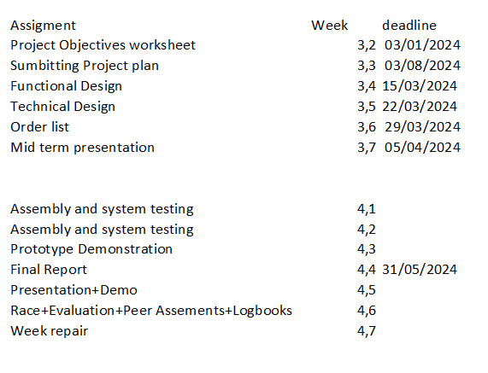

Risk analysis

There are a number of potential risks that can have an impact on a project of this type, that range from interpersonal, to the vehicle to the wider supply chain for the building of the vehicle.

Risk

The risks fall in four main categories, personnel, product, time management and supply chain. All but the supply chain risks can be actively managed from the beginning of the project in order to mitigate and minimise the potential harm caused by any problems that arise during the project. As the risk assessment was carried out, each potential risk was evaluated for possibility or likelihood and measured against the potential harm in the worst case scenario. The same analysis was conducted on those risks after the preventative measures were applied, and a second score was attributed. The results of that can be surmised as follows:
Type | Specifics | Unmitigated Risk | Mitigated Risk
Personnel | Conflict | High | Low
 | Sickness | Medium | Low
Product | Component/Part Failure | Medium | Low
 | Concept Failure | High | Low
 | Catastrophic Destruction | High | Low
Time Management | Missed Deadlines | High | Medium
Supply Chain | Missing Parts | Low

Further detail can be found in Appendix B at the end of the report.

Conclusion

There are a number of high risk scenarios when designing and building a project like this, though none that cannot be mitigated. Interpersonal conflict, accidental damage and poor time management should be managed on an individual basis, however it is the duty of all members to maintain the highest standards amongst their colleagues, while a strong design phase should limit the likelihood of a failure of concept design. For all potential risks, preventative solutions have been developed, not least an agreement across Thunderbolt ART with regards to the rules and regulations agreed to.

Bibliography
Grit, R. (2010). Project managment. Noordhoff Uitgevers.

Gantt chart
1st and 2nd Phase:
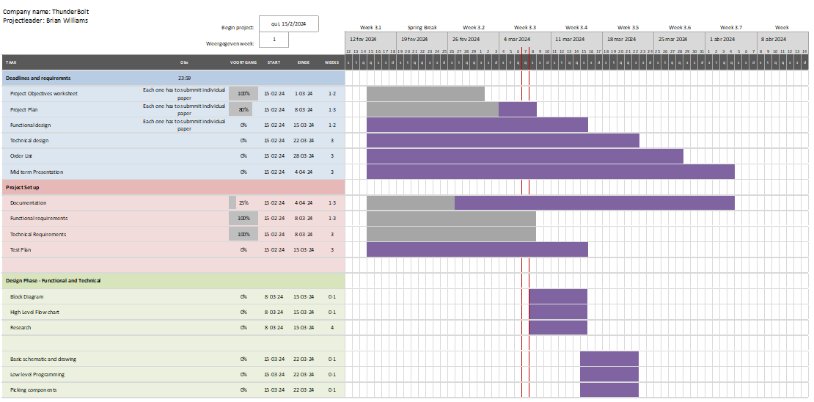
Table A-1
3rd , 4th and 5th Phase:
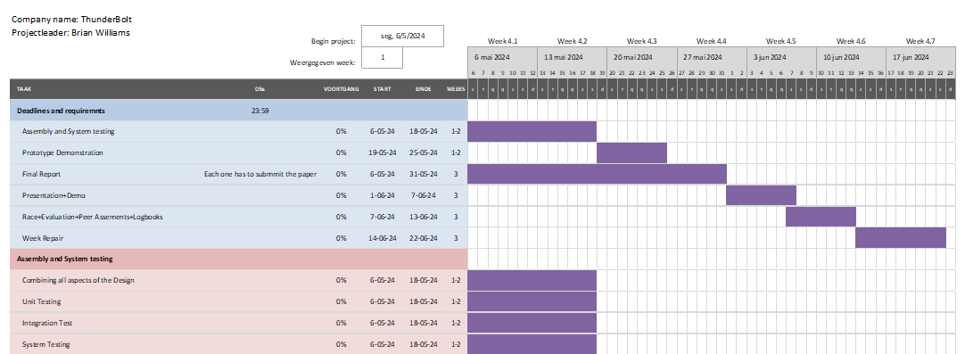
Table A-2

Appendix B Risk Assessment

The risks of the project software project broadly fall into four categories, personnel, product, material supply and time, which often intersect. The risks have been rated for (likelihood/damaged caused) firstly for the danger level without taking precautions with scores below each paragraph, with a further score in the same manner for the mitigated risk score.
Personnel
Conflict
Over the course of the duration of the project, there is potential for interpersonal conflict within the team to raise its head. Conflict may appear to come from nowhere, or it may fester for some time. It is important to address both situations well before they can develop into something bigger. The first step is creating a hierarchy that allows decisions to be made while retaining a strong element of collective input. It is important that everyone feels that their opinion can be heard even if a decision is ultimately made by the team not to act upon such an opinion. If everyone feels that they can make a fair contribution they will feel more valued.
There is also the possibility that external factors may have a detrimental effect on the mental health of any individual within the team. Such factors can go on to damage relations between team members when undeserved anger is directed someone else. The best method of combating this is each individual team member taking care of their own mental health, and if necessary forewarning other team members that they need space, whatever form that space takes.
Risk without taking precautions RA (3/3) 9
Risk while making Precautions RA (2/2) 4
Sickness/Absence
It is likely that over the course of the projects duration that one or more of the team members may take ill or become indisposed in some other manner. In the event that this is a short term affair it will cause an unnecessary delay, however if an absence stretches out into the long term, it may become a serious issue that could jeopardize the whole project. There are two elements to this, namely:
    - Workload
    - Data
A missing team member will increase the workload on the remaining members, which will increase stress and opportunities for mistakes to occur. It may also create resentment that members of the team aren’t doing their fair share. If data is not shared between teammates an absence will create a roadblock in the project, more delays. This can be mitigated by sharing data as a normal practice. Documents shared with suggestive edit rights will allow other team members to not only access work in someone else’s absence but to provide suggestions on the document while it is being worked on, providing an potential source of help for a struggling teammate.
Risk without taking precautions RA (2/2) 4
Risk while making Precautions RA (2/1) 2
Product
Concept Failure
It is possible that after completion of the functional design it is discovered that the detailed design proves impossible to return due to any number of circumstances, including but not limited to cost or material availability. The later we reach the detailed design stage, the greater a problem this poses. Therefore, a short but comprehensive functional design stage will be advantageous. The functional stage should return a solid basis for a design based on the specification and the laws of physics, if these requisites are followed all delays should be eliminated.
Risk without taking precautions RA (2/3) 6
Risk while making Precautions RA (1/1) 1
Component Failure
At any point during the project, it is possible that one or more of the parts placed on the vehicle or the mechanical vehicle itself may fail. In the event this happens the project will be delayed. Caught early enough these issues will be minimised, but failure to properly test the components, parts and chassis before their application to the final project could lead to unnecessary delays. In the event that a component fails on the board, work or testing on the board should cease, and the cause of the failure should be investigated and removed, before the component is replaced and the work continues.
Risk without taking precautions RA (3/2) 6
Risk while making Precautions RA (1/1) 1
Catastrophic Damage
Should due care and attention not be given to the care of the car, it is possible that an accident or incident may occur where the car is damaged to a degree where the final deadlines cannot be met, and the project must be deemed a failure. This can only happen through malice or incompetence, and it is the responsibility of everyone on the team to ensure that neither are an issue. Securing the item away after working on it also reduces the chances of it being involved in an accident that may damage it. Care should be taken while working on the project; if proper procedures are followed with lab equipment and when handling components and parts it will minimise the risk involved for accidents. Any accidents that may occur will also be of reduced severity.
Risk without taking precautions RA (3/3) 9
Risk while making Precautions RA (1/3) 3

Material Supply
Supply Chain Failure
Thunderbolt ART are reliant on both Saxion and Saxion’s providers to procure the parts, components and materials required to complete the project. In the event that the school or one of its suppliers should be unable to provide certain materials, it may cause a bottleneck in the design, particularly if the piece in question is of fundamental importance. While Saxion’s range of suppliers does mitigate this risk, it does remain an element outside of the control of Thunderbolt ART. The risk for this is low, however the potential fallout of such a problem could potentially be far reaching within the project.
Risk without taking precautions RA (1/3) 3
Time Management
Missed Deadlines
During Project Software, many teams found that despite believing they were on target for the deadlines that delays either pushed them right to the submission deadline or beyond. In the case of the Knights of the Strongbox, a team from which three members of Thunderbolt ART migrated, the final prototype was completed with under an hour of time left before the presentation. Learning from that experience will mean setting earlier deadlines and a firmer adherence to those deadlines. This applies throughout the whole project. Earlier time delays may be made up for, but could also snowball out oof control, while later delays could be catastrophic for the final submission of the project. Missing deadlines could also contribute to missteps in the design process or create tension within the personnel of the company. All members of Thunderbolt ART are responsible for ensuring their colleagues stay on track with the schedule.
Risk without taking precautions RA (3/3) 9
Risk while making Precautions RA (2/2) 4
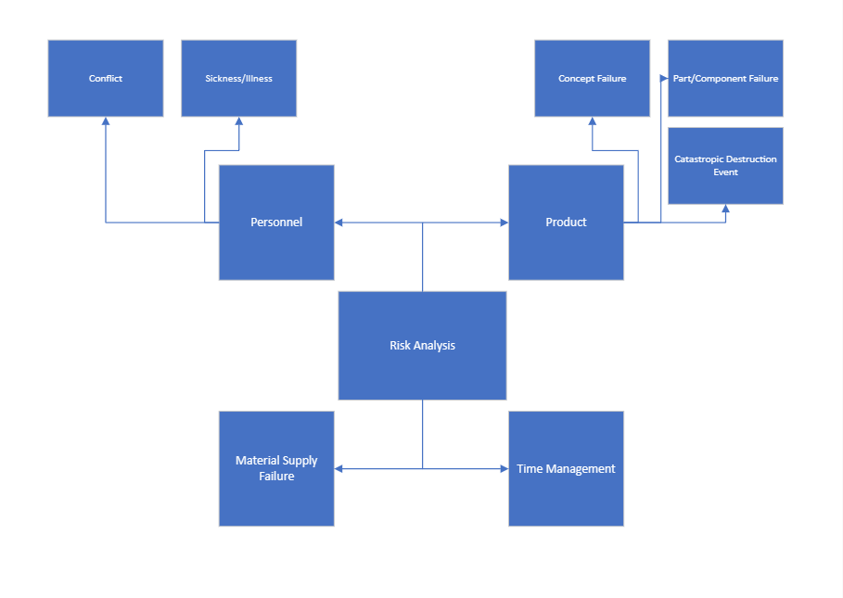
Figure B-1

